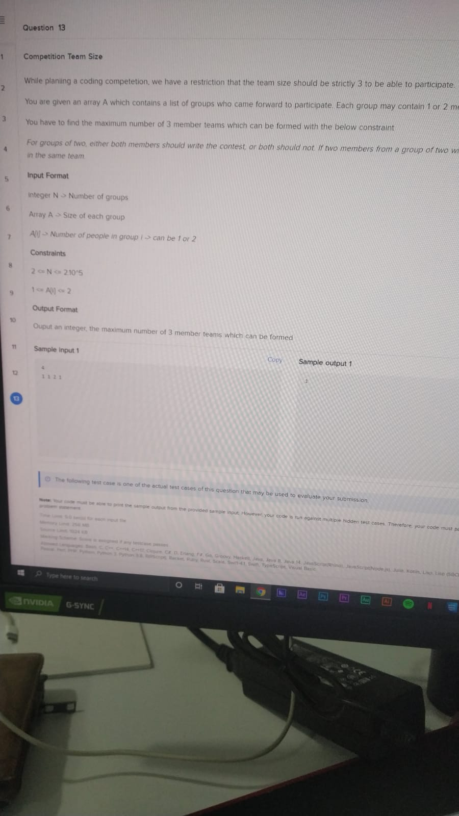
Question 13
Competition Team Size
While planiing a coding competetion, we have a restriction that the team size should be strictly 3 to be able to participate.
You are given an array A which contains a list of groups who came forward to participate. Each group may contain 1 or 2 m
You have to find the maximum number of 3 member teams which can be formed with the below constraint
For groups of two either both members should write the contest, or both should not If two members from a group of two w in the same team
Input Format
Integer N
Number of groups
Array A > Size of each group
A
> Number of people in group i > can be 1 or 2
Constraints
20 No 21015
1 All 2
Output Format
Ouput an integer, the maximum number of 3 member teams which can be formed
Sample input 1
Copy
Sample output 1
o
g
test case is one of the actual test cases of this question that may be used to evaluate your submission
sample outout from the provided sample input However your code is run against multiple hidden test cases. Therefore your code must
Pr
ere to search
NVIDIA
G-SYNC

